Photos:ACVA Logos:ACV logos eps:acva blue_black vertical.eps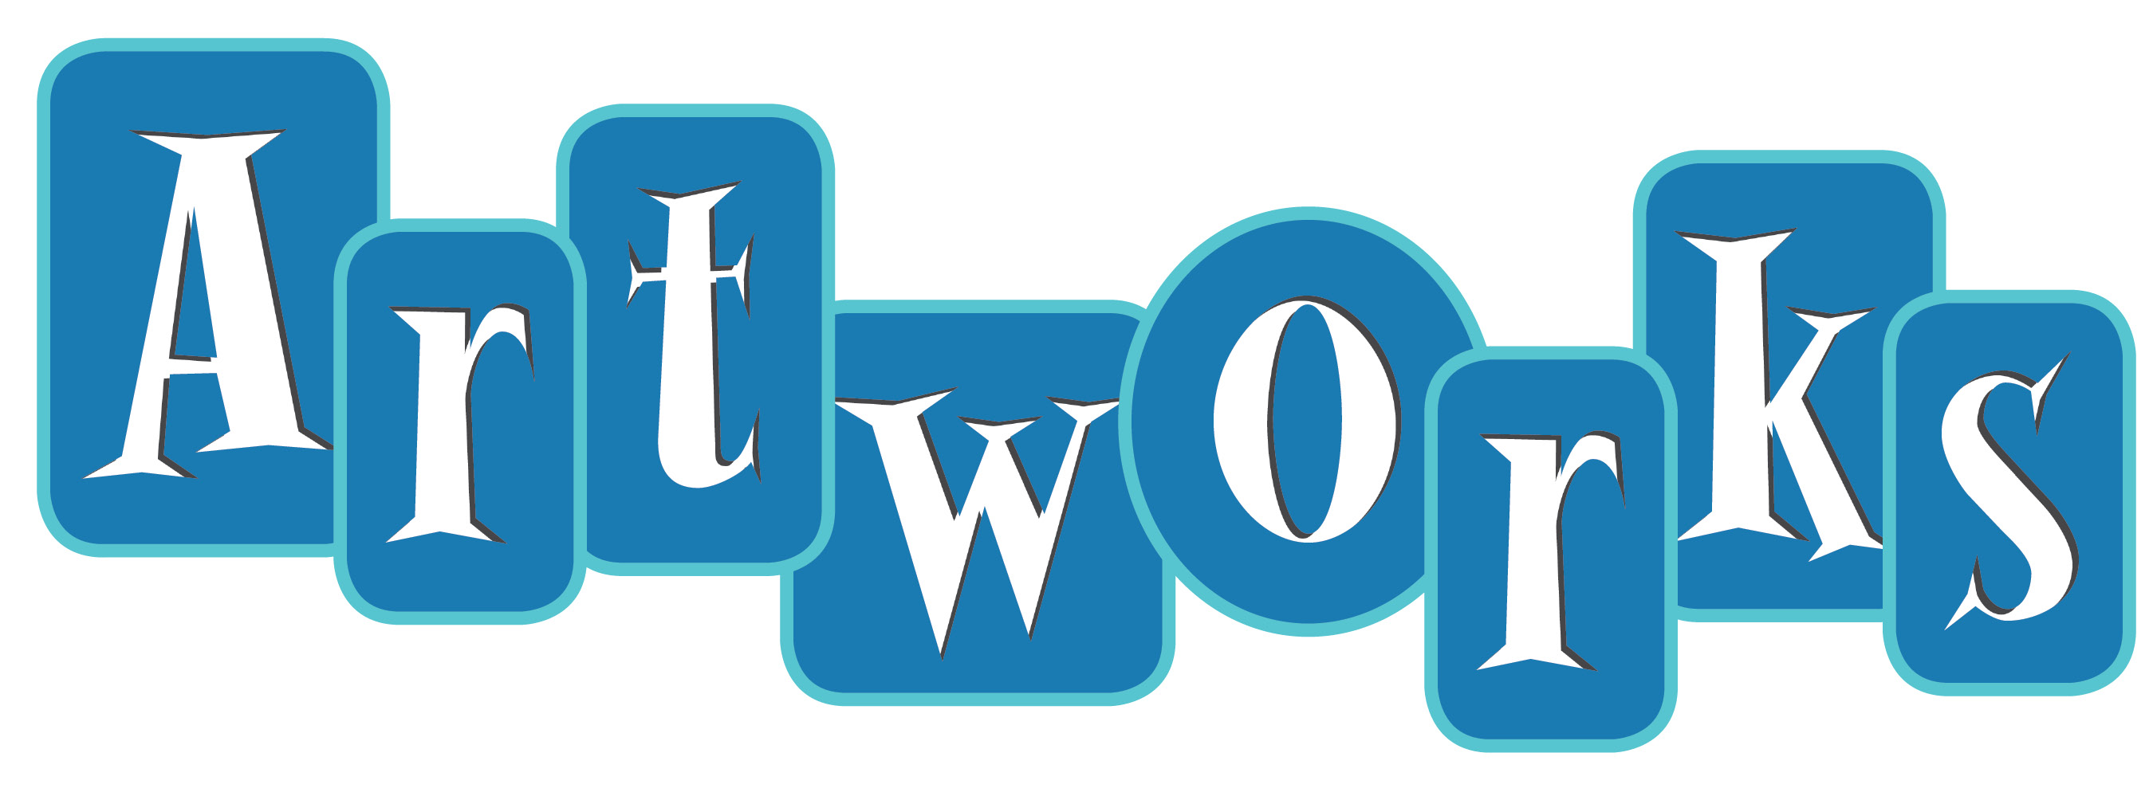

*One-of-a-kind hand-stamped cards created with love by*

*individuals with disabilities in Hampton Roads.*

***Wholesale Order Form***

Company Name: \_\_\_\_\_\_\_\_\_\_\_\_\_\_\_\_\_\_\_\_\_\_\_\_\_\_\_\_\_\_\_\_\_\_\_Contact Name: \_\_\_\_\_\_\_\_\_\_\_\_\_\_\_\_\_\_\_\_\_\_\_\_\_\_\_\_\_\_\_\_\_

Address: \_\_\_\_\_\_\_\_\_\_\_\_\_\_\_\_\_\_\_\_\_\_\_\_\_\_\_\_\_\_\_\_\_\_\_\_\_\_ City: \_\_\_\_\_\_\_\_\_\_\_\_\_\_\_\_\_\_\_\_State: \_\_\_\_\_\_Zip: \_\_\_\_\_\_\_\_\_\_\_

Telephone: \_\_\_\_\_\_\_\_\_\_\_\_\_\_\_\_\_Email: \_\_\_\_\_\_\_\_\_\_\_\_\_\_\_\_\_\_\_\_\_\_\_\_\_\_\_\_Website: \_\_\_\_\_\_\_\_\_\_\_\_\_\_\_\_\_\_\_\_\_\_\_\_\_\_\_\_

Pricing: $4 each or 3 for $10 50 - 100 Cards/$3 each 101 + Cards/$2 each

|  |  |  |  |  |  |  |  |
| --- | --- | --- | --- | --- | --- | --- | --- |
| Category | Quantity |  | Category | Quantity |  | Category | Quantity |
| Anniversary |  |  | Graduation |  |  | Sympathy |  |
| Baby |  |  | Halloween |  |  | Thank You |  |
| Birthday |  |  | Hannukah |  |  | Thinking of You |  |
| Christmas |  |  | Mother’s Day |  |  | Valentine’s Day |  |
| Easter |  |  | Real Estate |  |  | Wedding |  |
| Father’s Day |  |  | Retirement |  |  | Miscellaneous |  |
| Get Well |  |  | Sports |  |  | Custom |  |

|  |  |
| --- | --- |
| Total Quantity | Total Amount Due |
|  |  |

Please bill me for $\_\_\_\_\_\_\_\_ to the address above.

Enclosed is my payment in the amount of $\_\_\_\_\_\_.

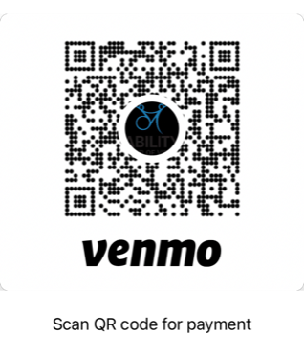Payment through Venmo (@abilitycenter) in the amount of $\_\_\_\_\_\_.

\_\_\_\_\_ Please include our company logo.

\_\_\_\_\_Please include the following message inside card:

**5825 Arrowhead Drive, Suite 201, Virginia Beach, VA 23465** | **(757) 497-7474** | **www.abilitycenterva.org**